BASIC STATISTICS ASSIGNMENT 2

**Estimation And Confidence Intervals**

# Building a 99% Confidence Interval for Printhead Durability Understanding the Problem:

We have a small sample of printhead durability data and want to estimate the population mean durability with 99% confidence. Since the population standard deviation is unknown, we'll use a t-distribution.

**Steps:**

* 1. **Calculate Sample Statistics:**
     + **Sample size (n):** 15
     + **Sample mean (x̄ ):** Calculate the average of the given data points.
     + **Sample standard deviation (s):** Calculate the standard deviation of the data.

# Determine the Critical Value (tα/2):

* + - **Degrees of freedom (df):** n - 1 = 14
    - **Confidence level (α):** 1 - 0.99 = 0.01
    - Use a t-distribution table or statistical software to find the t-value corresponding to a 99% confidence level and 14 degrees of freedom.

# Calculate the Margin of Error (E):

* + - E = tα/2 * (s / √n)

# Construct the Confidence Interval:

* + - Lower limit = x̄ - E
    - Upper limit = x̄ + E

# Rationale for using t-distribution:

* **Small sample size:** When the sample size is small (typically n < 30), the t- distribution is more appropriate than the normal distribution.
* **Unknown population standard deviation:** The t-distribution accounts for the uncertainty in estimating the population standard deviation from the sample standard deviation.

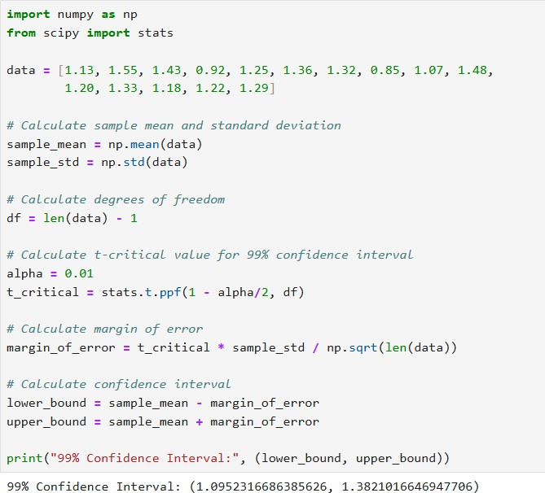

# Interpretation:

We are 99% confident that the true mean durability of the print-heads lies between the calculated lower and upper bounds. This means that if we were to repeat this experiment many times, 99% of the calculated confidence intervals would contain the true population mean.

# Building a 99% Confidence Interval with Known Population Standard Deviation

**Understanding the Problem:**

We have a small sample of printhead durability data and a known population standard deviation. We want to estimate the population mean durability with 99% confidence. Since we know the population standard deviation, we can use a z- distribution.

# Steps:

* 1. **Calculate Sample Mean (x̄ ):**
     + Calculate the average of the given data points.

# Determine the Critical Value (zα/2):

* + - **Confidence level (α):** 1 - 0.99 = 0.01
    - Use a z-table or statistical software to find the z-value corresponding to a 99% confidence level.

# Calculate the Margin of Error (E):

* + - E = zα/2 * (σ / √n)
    - σ is the known population standard deviation.

# Construct the Confidence Interval:

* + - Lower limit = x̄ - E
    - Upper limit = x̄ + E

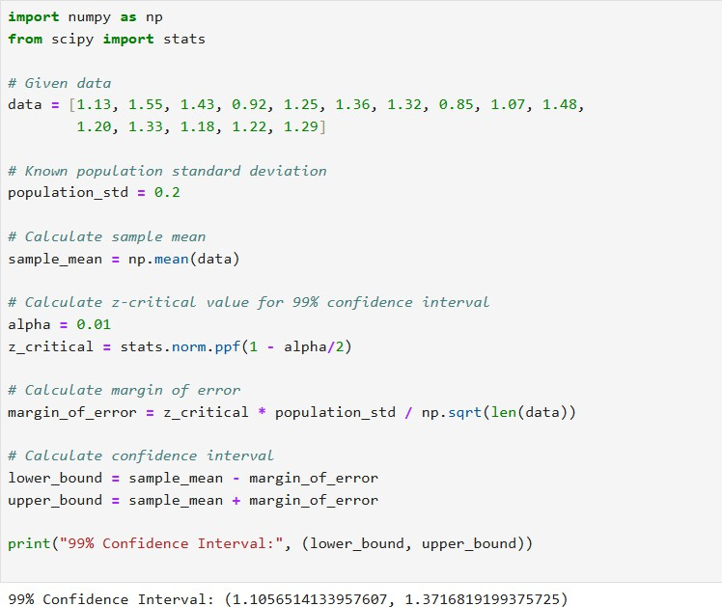

# Interpretation:

We are 99% confident that the true mean durability of the print-heads lies between the calculated lower and upper bounds. This means that if we were to repeat this experiment many times, 99% of the calculated confidence intervals would contain the true population mean.